EXP 2 -Regression and Optimization (Linear and Logistic regression)
Anusri .T
24BAD010
SCENARIO 1: Predict ocean water temperature using environmental and depth-related features.
OUTPUT:
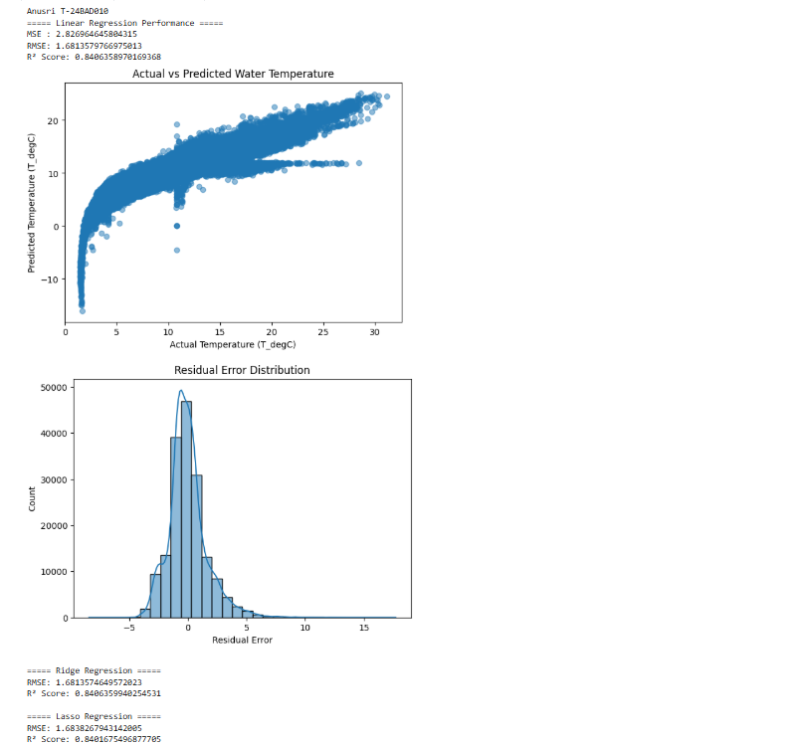

SCENARIO 2: Classify whether LIC stock price will increase (1) or decrease (0) based on historical data.
OUTPUT:
